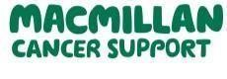
September - October 2026
CHFT Cancer Information and Support Service
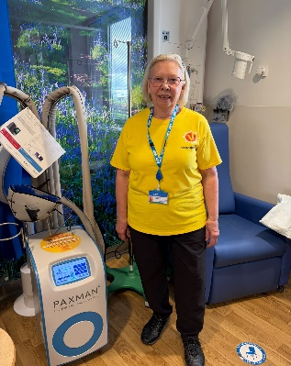
Welcome to the September/October newsletter for the Cancer Information and Support Service at Calderdale and Huddersfield NHS Foundation Trust,
For those who attend our walking group, which takes place on the first Thursday of each month, you will have met our lovely volunteer, Margaret. Margaret is now giving more of her time to support patients and the clinical team on the Greenlea Chemotherapy Unit at Huddersfield Royal Infirmary. If you see Margaret, please take the time to say ‘hello’.
As we extend our hello to Margaret, we are almost ready to say goodbye to Kate, our Cancer Support Worker, who will shortly be going on maternity leave.
Kate aims to be with us until the middle of October 2026 and will return in October 2027.
ANNUAL STOMA OPEN DAY
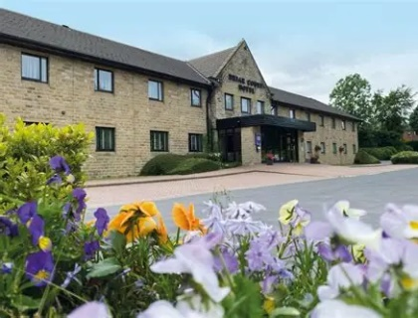
Do you have a stoma bag or are you supporting someone who does? If so, why not come along to the annual stoma open day on:
Wednesday 9th September between 10-3pm at Briar Court Hotel, Halifax Road, Huddersfield HD3 3NT.
At the event you will be able to view stoma care products, meet with nurses, company representatives, support groups and have a chat with others who are living with a stoma over a cuppa.
This is a free event with plenty of free onsite car parking.
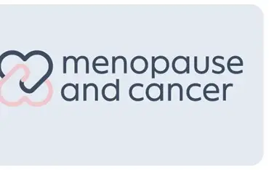
MENOPAUSE & CANCER:
Menopause can be a significant life transition at any stage of life. When cancer is added to the picture, the physical and emotional changes can feel relentless, confusing and deeply personal.
Cancer treatments can sometimes trigger menopause earlier or more suddenly than expected. Understanding what is happening to your body. Knowing that support is available — can make a real difference.
There are some local resources available to help support patients:

Our Menopause & Cancer Community Support Sessions provide a safe and supportive space to talk openly about the changes that can follow cancer treatment.

Together, we’ll explore:
- Why some cancer treatments can trigger menopause and what this can mean for your body.
- The symptoms that women don’t always feel comfortable talking about, from brain fog and fatigue to changes in intimacy and relationships.
- Practical strategies and treatment options that may help you manage symptoms.
- Useful information, resources and ideas to help you feel more like yourself again.
- Community Support Sessions

You can join the monthly sessions, where you’ll explore different aspects of menopause and cancer. Each session combines expert information, practical tips and plenty of time for open discussion in a safe, welcoming and supportive environment.

You’ll have the opportunity to ask questions, share experiences and connect with others who understand what you’re going through.

The aim is for you to leave each session feeling more informed, reassured and less alone, with knowledge, ideas and resources to support you in your day-to-day life.

Whether you’re looking for answers, connection, or simply a friendly space to talk
All sessions are free and open to anyone affected by menopause after cancer.

Upcoming sessions in Huddersfield:
Wednesday 16 September | 11:30am–1:00pm
Huddersfield: Menopause & Cancer Community Support Sessions

Wednesday 14 October | 11:30am–1:00pm
Huddersfield: Menopause & Cancer Community Support Sessions

You can book these on the following link:
https://www.eventbrite.co.uk/e/huddersfield-menopause-cancer-community-support-sessions-tickets-1995933839844

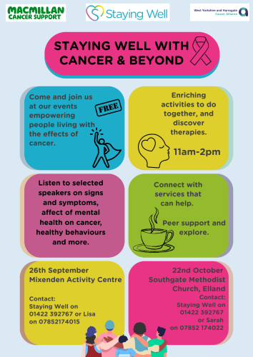

LOOKING AFTER YOUR MENTAL HEALTH DURING AND AFTER CANCER


A cancer diagnosis and treatment can affect much more than physical health. It is completely understandable to experience worry, anxiety, low mood, anger, uncertainty or feelings of isolation at different points in your cancer journey. Support is available locally across Calderdale and Kirklees, and you do not have to wait until things feel overwhelming before asking for help.

For adults receiving their main cancer care through Calderdale and Huddersfield NHS Foundation Trust, the Cancer Psychological Services team provides specialist psychological support for difficulties related to cancer, including anxiety, low mood, fear about the future, adjusting to diagnosis and changes in relationships, appearance or daily life. Support can include evidence-based psychological therapies and is available at Huddersfield Royal Infirmary and Calderdale Royal Hospital, as well as by telephone or secure video appointment. You can speak to your Consultant, Clinical Nurse Specialist or Cancer Information Support Service team if you feel a referral would be helpful.

There is also wider community support available. Healthy Minds Calderdale provides a range of mental health and wellbeing services for people in Calderdale, whether or not they have a formal mental health diagnosis. Its SafeSpace service offers free emotional support for people aged 16 and over who are feeling distressed or overwhelmed. For people affected by cancer who would benefit from practical and wellbeing support, Staying Well, who can be contacted on 01422 392767, offers personalised help with wellbeing, social connection and accessing local services.

If you are struggling with your mental health, please talk to someone you trust or contact your GP or cancer team. If you need urgent emotional support, the Samaritans can be contacted free, 24 hours a day, on 116 123. You are not alone, and asking for support is an important part of looking after yourself during your cancer journey.

LOCAL SOCIAL


Many of our patients value the opportunity to meet with others who understand the reality of living with cancer.
Whether you have a strong support network or live alone, having the opportunity to spend time with others who understand how it feels can make a huge difference.

In addition to the CHFT Men’s and Women’s Support Groups, Julie, a friend of our service has created a patient-led group that meets monthly. There is no formal structure to the meetings, it is simply a relaxed and friendly gathering for patients, carers and loved ones to meet, chat and support one another.

The next meeting will be held on Wednesday 16th September 2026, from 10am–12 noon.
Toby Carvery
Brighouse Road
Huddersfield
HD2 2LB
RETURNING TO WORK AFTER CANCER
Returning to work after cancer treatment can be an important step, but it can also bring uncertainty. You may be worried about fatigue, ongoing treatment or side effects, changes in your confidence, or how your employer and colleagues will respond. There is no single ‘right’ way to return to work, and it is important to consider what is manageable for you.

Macmillan Cancer Support has a range of advice and resources specifically for people affected by cancer who are thinking about returning to work. This includes information about talking to your employer, creating a return-to-work plan, managing ongoing side effects and understanding reasonable adjustments. Adjustments might include a phased return, reduced or flexible hours, additional breaks or changes to your duties. Macmillan also provides advice about employment rights, finances and work-related concerns through its Support Line on 0808 808 0000.

If you are looking for work, changing career or would like help rebuilding your confidence after a period away from employment, Calderdale Council's Employment Hub provides free support for Calderdale residents aged 16 and over. This includes help with identifying skills and strengths, CVs and applications, interview preparation, training and work experience. The service specifically welcomes people who are returning to work.


It can also be helpful to speak with your employer or occupational health team before returning. You and your manager can agree a flexible return-to-work plan and review it regularly as you see how you manage. If you have ongoing health needs, your healthcare professional may also be able to provide a fit note outlining what you can and cannot currently do at work.

Remember: returning to work does not have to mean going straight back to your previous hours or workload. Taking things gradually and asking for appropriate support can help make the transition more manageable.

Men’s Cancer Support Group: is hosted at the Legends café at the Accu Stadium, Huddersfield. Soft drinks are provided from 2-4pm. All men affected by cancer either as patients, family members and carers are welcome to attend. Our next meetings are on: 24th September and 29th October 2026
Please note this is a free event with free parking on site.

Women’s Support Group: is hosted at the Legends café at the Accu Stadium, Huddersfield. Drinks are provided from 2-4pm. The group is open to women affected by cancer either as patients, family members or carers are welcome. Our next meetings are on: 30th September and 28th October 2026. Please note this is a free event with parking on site.

Working with the charity Look Good Feel Better, we are pleased to offer step by step advice on skincare and makeup application to complete a natural, radiant look. Learn practical tips and techniques, including how to enhance sparse eyebrows or loss of eyelashes, to help you look and feel like you again. Each participant will be provided with a complimentary range of products within this session. The next sessions will take place at Briar Court Hotel on 10th September and 8th October 2026, from 2:00pm-4.15pm. To secure your place please use the following link: https://lookgoodfeelbetter.co.uk/workshops/?type=facetoface&iam=Woman&k_1=1&postcode=HD3+3JL&morning=1&afternoon=1&evening=1&any=1&submit=View+Workshops

Walking Group First Thursday of each month at 10:30am:
The walking group at CHFT is a friendly and social space for anyone affected by cancer, including patients, their relatives or carers. The group meets on the 1st Thursday of each month at 10:30am at the Conservatory at the bottom of Greenhead Park, Trinity Street, Huddersfield, HD1 4DT. Participants can enjoy gentle walks suitable for all abilities, followed by a drink in the Conservatory. The group is open to all, whether currently undergoing treatment or living beyond cancer. Please note, it is card only payments in the café.

If you would like to speak to a member of the
Cancer Information and Support Service, please get in touch.
You can telephone us on:01422 222709 or 01484 343614

